ตัวอย่าง Packaging

[](http://www.google.co.th/url?sa=i&rct=j&q=&esrc=s&source=images&cd=&ved=0CAcQjRxqFQoTCLCT9L6j6ccCFQUJjgodlJwNCw&url=http://thai.alibaba.com/product-gs/food-paper-box-snack-box-1478101585.html&psig=AFQjCNEiBAj3wcV9iwhyJcVYOKHdws8heA&ust=1441864892856730)[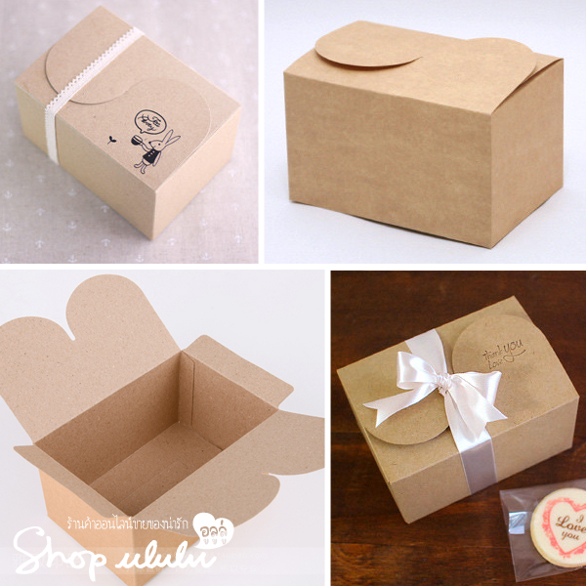](http://www.google.co.th/url?sa=i&rct=j&q=&esrc=s&source=images&cd=&cad=rja&uact=8&ved=0CAcQjRxqFQoTCK7dysql6ccCFVAEjgoddwYLpQ&url=http://shop-ululu.com/shop/%E0%B8%81%E0%B8%A5%E0%B9%88%E0%B8%AD%E0%B8%87%E0%B8%82%E0%B8%99%E0%B8%A1%E0%B8%82%E0%B8%AD%E0%B8%87%E0%B8%82%E0%B8%A7%E0%B8%B1%E0%B8%8D-curve-lock-%E0%B8%81%E0%B8%A3%E0%B8%B0%E0%B8%94%E0%B8%B2-2/&psig=AFQjCNEiBAj3wcV9iwhyJcVYOKHdws8heA&ust=1441864892856730)

[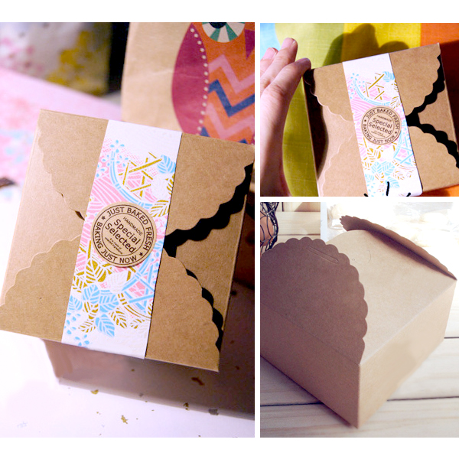](http://www.google.co.th/url?sa=i&rct=j&q=&esrc=s&source=images&cd=&cad=rja&uact=8&ved=0CAcQjRxqFQoTCOCUmo2m6ccCFcMHjgodO74M4g&url=http://shop-ululu.com/shop/%E0%B8%81%E0%B8%A5%E0%B9%88%E0%B8%AD%E0%B8%87%E0%B8%82%E0%B8%99%E0%B8%A1%E0%B8%82%E0%B8%AD%E0%B8%87%E0%B8%82%E0%B8%A7%E0%B8%B1%E0%B8%8D-%E0%B8%81%E0%B8%A3%E0%B8%B0%E0%B8%94%E0%B8%B2%E0%B8%A9%E0%B8%84/&psig=AFQjCNEiBAj3wcV9iwhyJcVYOKHdws8heA&ust=1441864892856730)[](http://www.google.co.th/url?sa=i&rct=j&q=&esrc=s&source=images&cd=&cad=rja&uact=8&ved=0CAcQjRxqFQoTCKXzrKCn6ccCFYkLjgods8sMUQ&url=http://thai.alibaba.com/product-gs/fast-food-disposable-snack-box-719544697.html&psig=AFQjCNEiBAj3wcV9iwhyJcVYOKHdws8heA&ust=1441864892856730)

[](http://www.google.co.th/url?sa=i&rct=j&q=&esrc=s&source=images&cd=&cad=rja&uact=8&ved=0CAcQjRxqFQoTCJKeoLin6ccCFZRKjgodjOYA2w&url=http://www.be2hand.com/949091-%E0%B8%A3%E0%B8%B1%E0%B8%9A%E0%B8%9C%E0%B8%A5%E0%B8%B4%E0%B8%95%E0%B9%81%E0%B8%A5%E0%B8%B0%E0%B8%88%E0%B8%B3%E0%B8%AB%E0%B8%99%E0%B9%88%E0%B8%B2%E0%B8%A2%E0%B8%81%E0%B8%A5%E0%B9%88%E0%B8%AD%E0%B8%87%E0%B8%9C%E0%B9%89%E0%B8%B2%E0%B9%84%E0%B8%AB%E0%B8%A1%E0%B9%83%E0%B8%AA%E0%B9%88%E0%B8%82%E0%B8%99%E0%B8%A1%E0%B9%84%E0%B8%AB%E0%B8%A7%E0%B9%89%E0%B8%9E%E0%B8%A3%E0%B8%B0%E0%B8%88%E0%B8%B1%E0%B8%99%E0%B8%97%E0%B8%A3%E0%B9%8C%E0%B8%A3%E0%B8%B2%E0%B8%84%E0%B8%B2%E0%B8%96%E0%B8%B9%E0%B8%81-%E0%B9%82%E0%B8%97%E0%B8%A3.082-3863228.html&psig=AFQjCNEiBAj3wcV9iwhyJcVYOKHdws8heA&ust=1441864892856730)[](http://www.google.co.th/imgres?imgurl=http://ce.lnwfile.com/iwofri.jpg&imgrefurl=http://www.slowlife88.com/category/47/%E0%B8%81%E0%B8%A5%E0%B9%88%E0%B8%AD%E0%B8%87-%E0%B8%96%E0%B8%B8%E0%B8%87-%E0%B8%90%E0%B8%B2%E0%B8%99%E0%B8%A3%E0%B8%AD%E0%B8%87%E0%B9%80%E0%B8%84%E0%B9%89%E0%B8%81-%E0%B8%A3%E0%B8%B4%E0%B8%9A%E0%B8%9A%E0%B8%B4%E0%B9%89%E0%B8%99-%E0%B9%80%E0%B8%8A%E0%B8%B7%E0%B8%AD%E0%B8%81/%E0%B8%81%E0%B8%A5%E0%B9%88%E0%B8%AD%E0%B8%87%E0%B8%81%E0%B8%A3%E0%B8%B0%E0%B8%94%E0%B8%B2%E0%B8%A9&h=540&w=540&tbnid=dLRv_BokQe5BgM:&docid=KlXm7gNEZ5mpZM&ei=S9DvVabIK8fJuASszLi4Aw&tbm=isch&ved=0CHIQMyhQMFBqFQoTCOaZ3aCo6ccCFcckjgodLCYONw)

[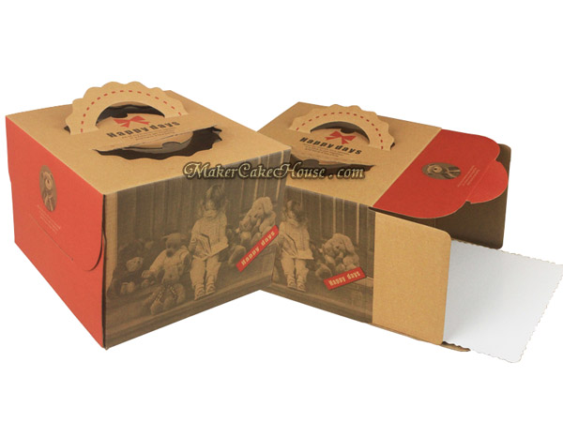](http://www.google.co.th/url?sa=i&rct=j&q=&esrc=s&source=images&cd=&cad=rja&uact=8&ved=0CAcQjRxqFQoTCLH1j-uo6ccCFYiOjgodQw8MKQ&url=http://www.makercakehouse.com/product/211/%E0%B8%81%E0%B8%A5%E0%B9%88%E0%B8%AD%E0%B8%87%E0%B9%83%E0%B8%AA%E0%B9%88%E0%B9%80%E0%B8%84%E0%B9%89%E0%B8%81%E0%B8%81%E0%B8%A3%E0%B8%B0%E0%B8%94%E0%B8%B2%E0%B8%A9%E0%B8%84%E0%B8%A3%E0%B8%B2%E0%B8%9F%E0%B8%97%E0%B9%8C-%E0%B8%A5%E0%B8%B2%E0%B8%A2%E0%B9%80%E0%B8%94%E0%B9%87%E0%B8%81-3-%E0%B8%9B%E0%B8%AD%E0%B8%99%E0%B8%94%E0%B9%8C&bvm=bv.102022582,d.c2E&psig=AFQjCNHd0IgYmEsJr8I9X3ETzA32adOfZA&ust=1441866188294453)

[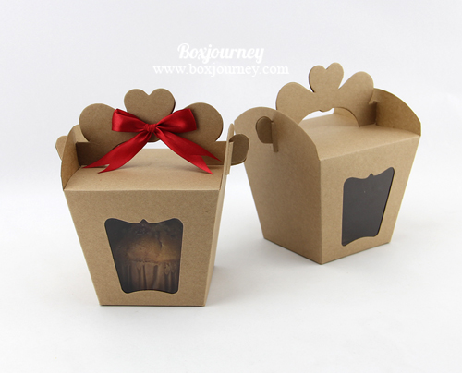](http://www.google.co.th/url?sa=i&rct=j&q=&esrc=s&source=images&cd=&cad=rja&uact=8&ved=0CAcQjRxqFQoTCLH1j-uo6ccCFYiOjgodQw8MKQ&url=http://www.boxjourney.com/product.html?cid%3D17&bvm=bv.102022582,d.c2E&psig=AFQjCNHd0IgYmEsJr8I9X3ETzA32adOfZA&ust=1441866188294453)[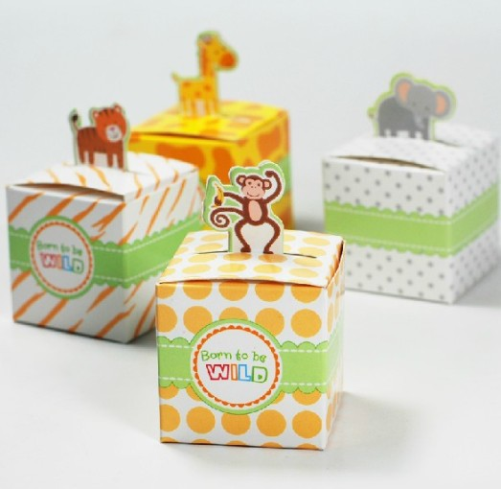](http://www.google.co.th/url?sa=i&rct=j&q=&esrc=s&source=images&cd=&cad=rja&uact=8&ved=0CAcQjRxqFQoTCKG1vaam6ccCFZGRjgodvdgIBA&url=http://th.aliexpress.com/item/Lovely-selva-animals-paper-candy-box-for-baby-shower/1045506845.html&psig=AFQjCNEiBAj3wcV9iwhyJcVYOKHdws8heA&ust=1441864892856730)

[](http://www.google.co.th/url?sa=i&rct=j&q=&esrc=s&source=images&cd=&cad=rja&uact=8&ved=0CAcQjRxqFQoTCNibhfGl6ccCFcsfjgodbDgPTQ&url=http://www.bakerymaker.com/?450,%E0%B8%81%E0%B8%A5%E0%B9%88%E0%B8%AD%E0%B8%87%E0%B8%82%E0%B8%99%E0%B8%A1-%E0%B9%80%E0%B8%84%E0%B9%89%E0%B8%81-%E0%B8%84%E0%B8%B8%E0%B9%8A%E0%B8%81%E0%B8%81%E0%B8%B5%E0%B9%89-(%E0%B8%AA%E0%B8%B5%E0%B9%81%E0%B8%94%E0%B8%87)-%E0%B9%81%E0%B8%9E%E0%B8%84-5-%E0%B9%83%E0%B8%9A&psig=AFQjCNEiBAj3wcV9iwhyJcVYOKHdws8heA&ust=1441864892856730)[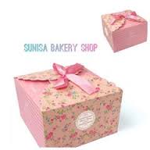](http://www.google.co.th/imgres?imgurl=https://fbcdn-photos-c-a.akamaihd.net/hphotos-ak-xfl1/v/t1.0-0/p240x240/11986470_929562320432280_8203320033495828194_n.jpg?oh%3D8e8cab89e705d4fa4e8a2696e3e6c98d%26oe%3D5666B66C%26__gda__%3D1449704561_be33c028b128b61b69a36f2e86a10a35&imgrefurl=https://th-th.facebook.com/Sunisabakeryshop&h=240&w=240&tbnid=wPYBnxT4ISn1uM:&docid=8m30JA4dteG8tM&ei=19HvVeuCFoq8ugSe7oHICA&tbm=isch&ved=0CCsQMygoMCg4yAFqFQoTCKvKsd2p6ccCFQqejgodHncAiQ)

[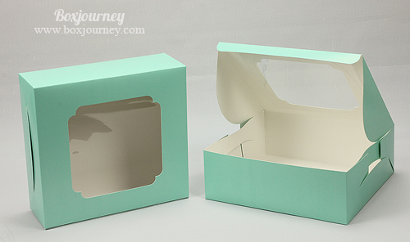](http://www.google.co.th/url?sa=i&rct=j&q=&esrc=s&source=images&cd=&cad=rja&uact=8&ved=0CAcQjRxqFQoTCMeKiemk6ccCFcMajgodQF0GkA&url=http://www.boxjourney.com/product.html?cid%3D3&psig=AFQjCNEiBAj3wcV9iwhyJcVYOKHdws8heA&ust=1441864892856730)[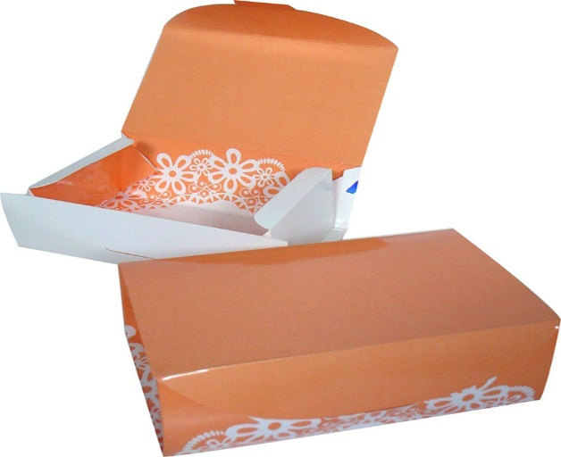](http://www.google.co.th/url?sa=i&rct=j&q=&esrc=s&source=images&cd=&cad=rja&uact=8&ved=0CAcQjRxqFQoTCIbvwLSl6ccCFRBxjgodqngJ6A&url=http://market.onlineoops.com/505181&psig=AFQjCNEiBAj3wcV9iwhyJcVYOKHdws8heA&ust=1441864892856730)

[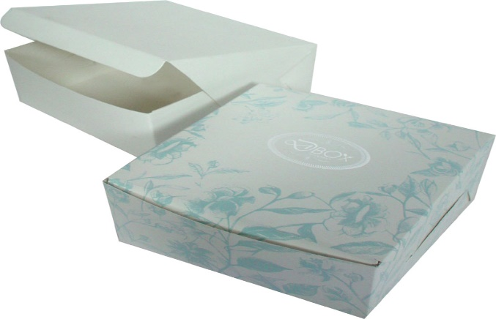](http://www.google.co.th/url?sa=i&rct=j&q=&esrc=s&source=images&cd=&cad=rja&uact=8&ved=0CAcQjRxqFQoTCOHE9Ian6ccCFYNxjgodCakOdA&url=http://cboxd.nalueng.com/products?action%3Dview%26id%3D20008&psig=AFQjCNEiBAj3wcV9iwhyJcVYOKHdws8heA&ust=1441864892856730)

[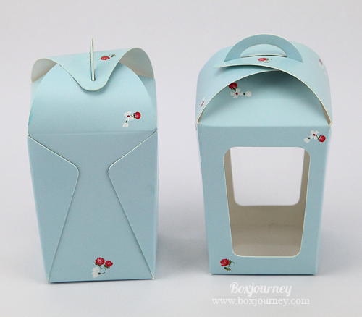](http://www.google.co.th/url?sa=i&rct=j&q=&esrc=s&source=images&cd=&cad=rja&uact=8&ved=0CAcQjRxqFQoTCL6ko5yl6ccCFVQHjgodGqsHWA&url=http://www.boxjourney.com/product.html?cid%3D18&psig=AFQjCNEiBAj3wcV9iwhyJcVYOKHdws8heA&ust=1441864892856730)

[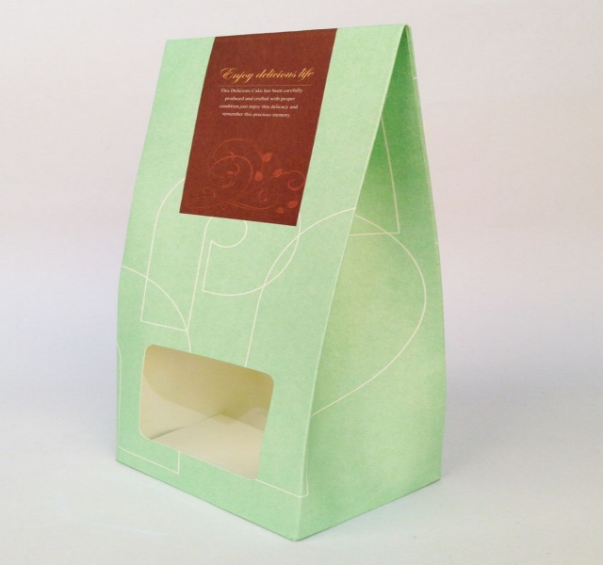](http://www.google.co.th/url?sa=i&rct=j&q=&esrc=s&source=images&cd=&cad=rja&uact=8&ved=0CAcQjRxqFQoTCIrEoNGk6ccCFVAcjgodHtoH3w&url=http://www.bakerymaker.com/?710,%E0%B8%81%E0%B8%A5%E0%B9%88%E0%B8%AD%E0%B8%87%E0%B8%82%E0%B8%99%E0%B8%A1-%E0%B8%84%E0%B8%B8%E0%B9%8A%E0%B8%81%E0%B8%81%E0%B8%B5%E0%B9%89-%E0%B8%AA%E0%B8%B5%E0%B9%80%E0%B8%82%E0%B8%B5%E0%B8%A2%E0%B8%A7%E0%B8%AD%E0%B9%88%E0%B8%AD%E0%B8%99-(5-%E0%B9%83%E0%B8%9A)&psig=AFQjCNEiBAj3wcV9iwhyJcVYOKHdws8heA&ust=1441864892856730)

[](http://www.google.co.th/url?sa=i&rct=j&q=&esrc=s&source=images&cd=&cad=rja&uact=8&ved=&url=http://www.atelieralicante.com/lifestyle/hola-primavera-hola-comuniones&psig=AFQjCNEiBAj3wcV9iwhyJcVYOKHdws8heA&ust=1441864892856730)

[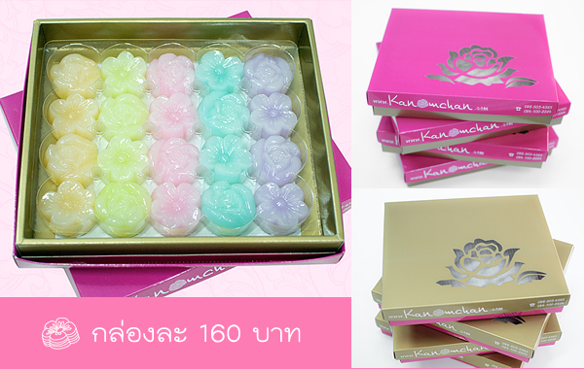](http://www.google.co.th/url?sa=i&rct=j&q=&esrc=s&source=images&cd=&cad=rja&uact=8&ved=0CAcQjRxqFQoTCOm3v7ym6ccCFZXFjgodu3gFYg&url=http://www.kanomchan.com/Menu2.php&psig=AFQjCNEiBAj3wcV9iwhyJcVYOKHdws8heA&ust=1441864892856730)