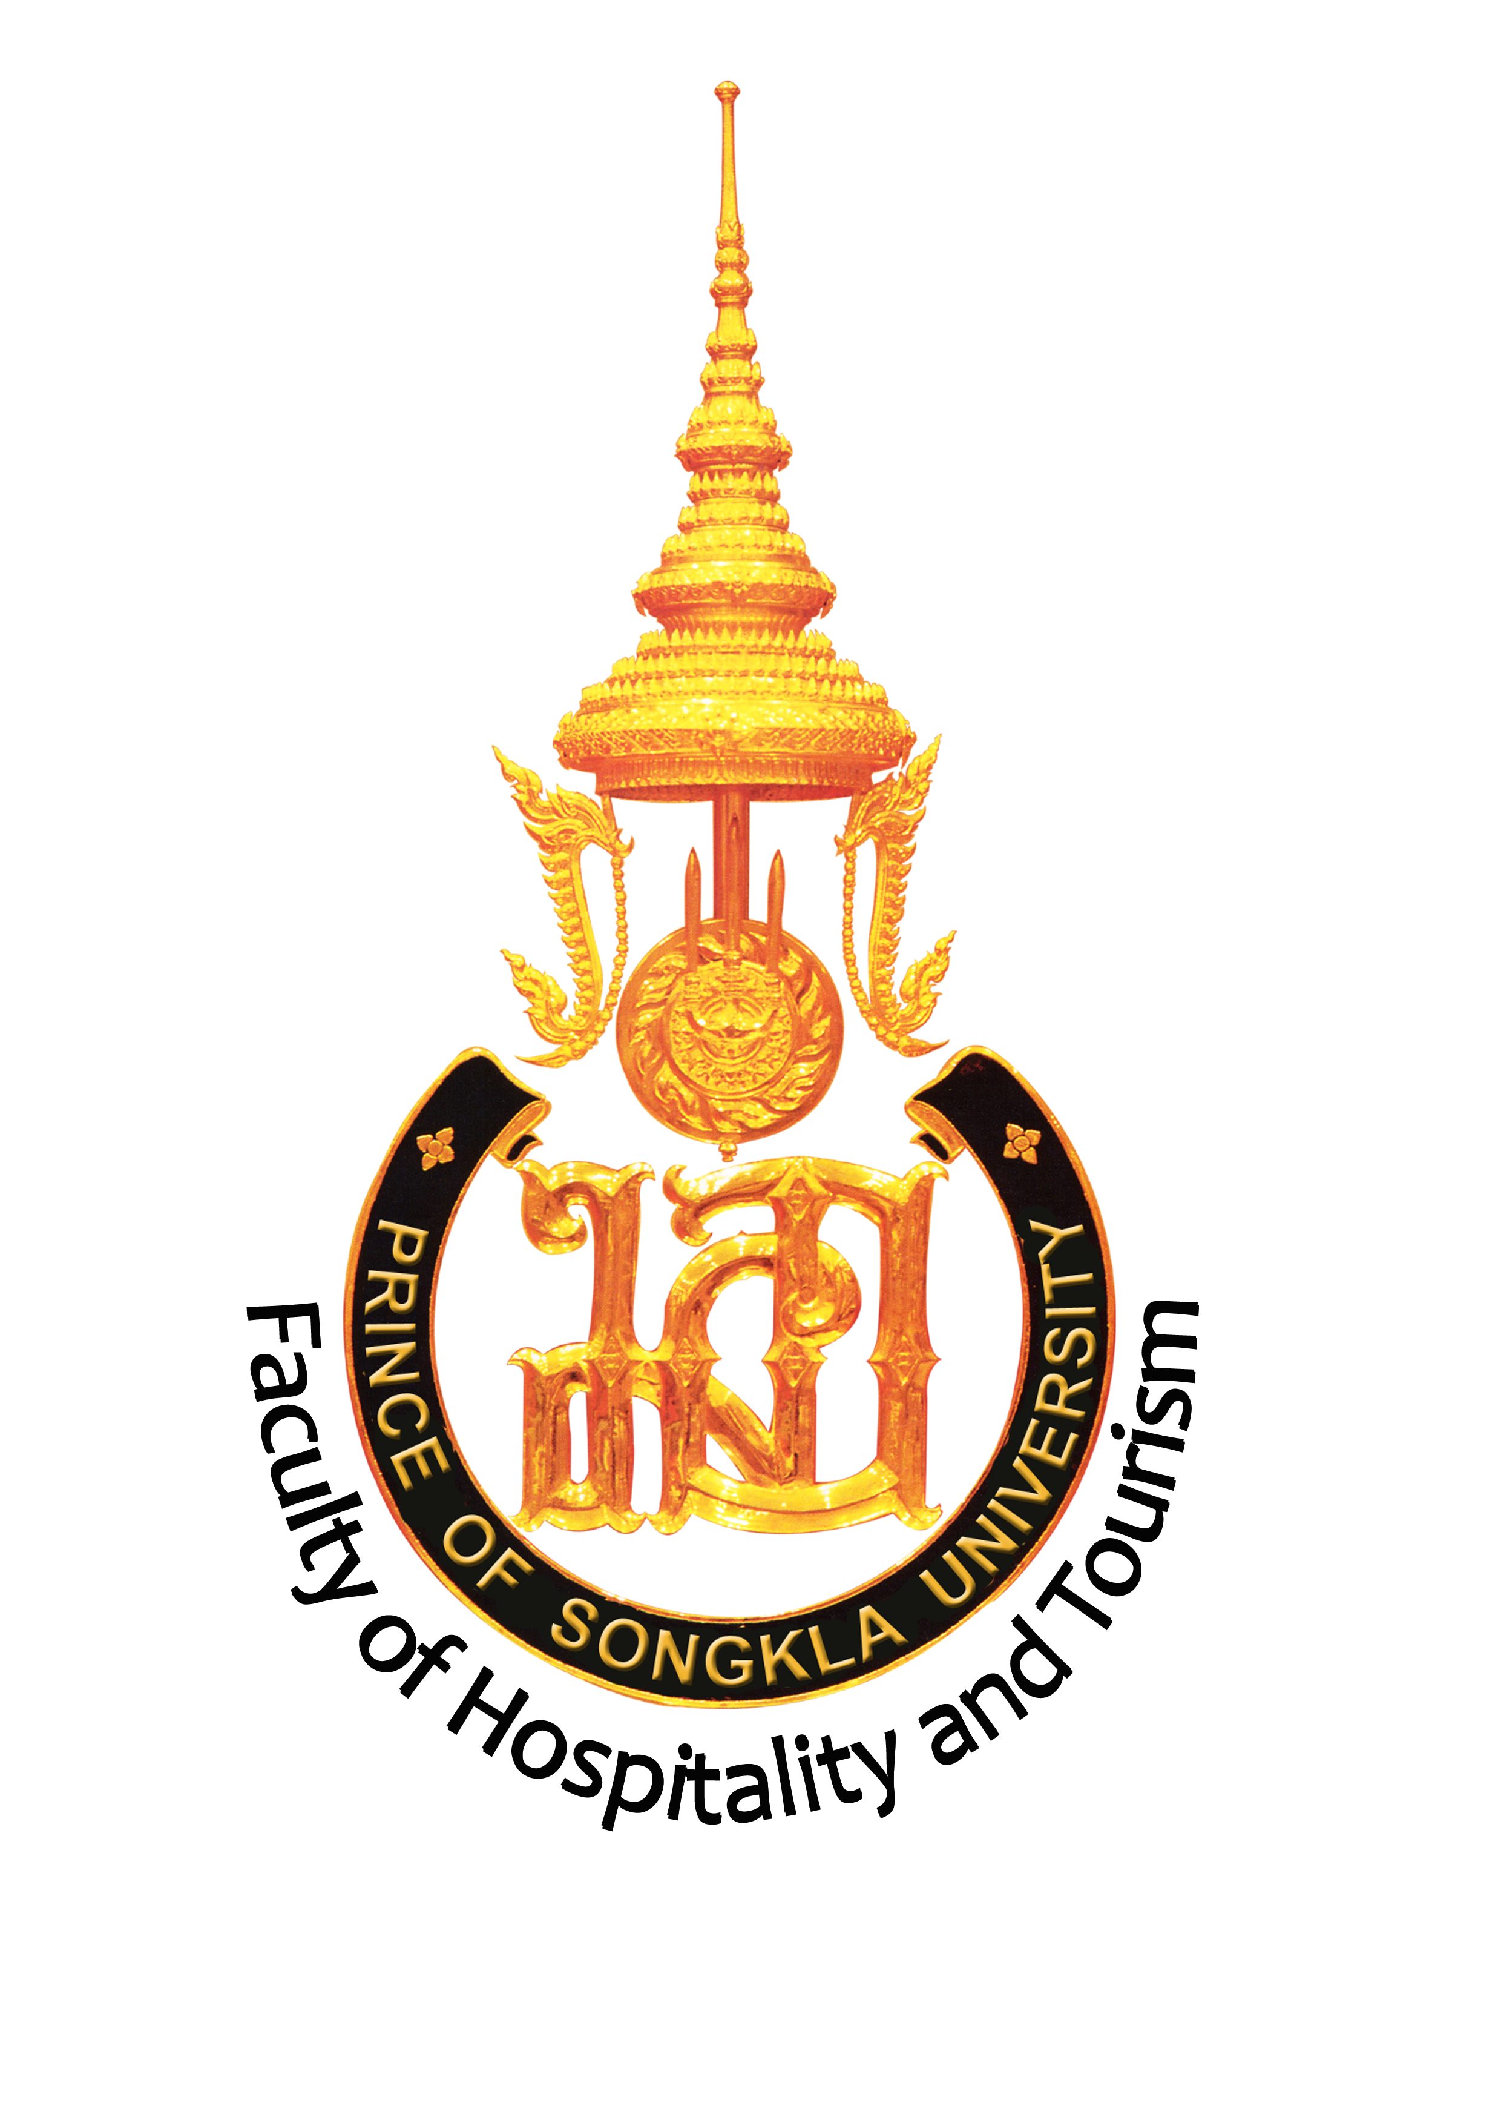 | 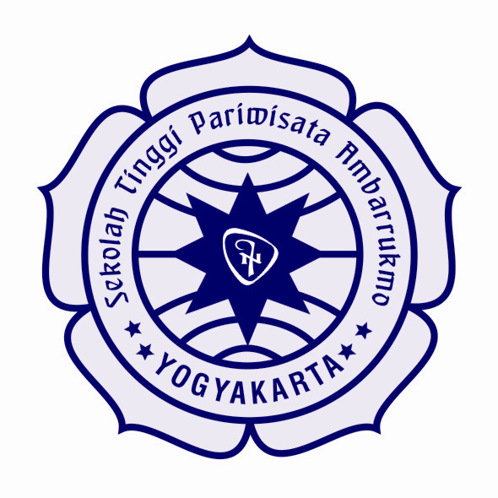
Memorandum of Agreement (MOA)
Between
Faculty of Hospitality and Tourism, Prince of Songkla University
And
Sekolah Tinggi Pariwisata Ambarrukmo (STiPRAM)

Faculty of Hospitality and Tourism (FHT), Prince of Songkla University, Phuket Campus (PSU), Thailand, and Sekolah Tinggi Pariwisata Ambarrukmo (STiPRAM), Indonesia, believe that mutual benefits can be derived by bridging their two institutions, achieving a closer relationship by linking their scholars and students. Both institutions share strong convictions that mutual understanding among people can be promoted through the establishment of academic links. Therefore, both institutions agree to enter into this Memorandum of Agreement by agreeing to the following:

- Area of implementation
The 3 + 1 Program

- Implementation
- This MOA is intended to form a basis upon which FHT PSU and STiPRAM may transfer and accept students from each institution. The program consists of a three year study at home university and a transfer into the fourth year study at host university. Each host university will award their relevant Bachelor’s degree to the transfer student who completes the degree requirement.

- Both institutions have carried out ‘curriculum and level match’ checks between the programmes mentioned in 3) and are satisfied that there is an adequate match between the content and levels of the programmes to facilitate student transfer.

- STiPRAM students transferred to FHT PSU
  - FHT PSU will accept STiPRAM’s BA Tourism students who have:
    - Competed 3rd year of BA Tourism with a minimum GPA of 2.5 out of 4.00.
    - Minimum TOEIC score of 550 or equivalent of IELTS and TOEFL or an average GPA of previous of 4 English courses at STiPRAM of 2.5 out of 4.00.
  - STiPRAM students are eligible to be awarded FHT PSU’s BBA in Tourism Management degree provided that
    - They complete all subjects in the study plan in Annex 1 with GPA of 2.5 out of 4.00.
    - Obtain minimum TOEIC score of 630 or equivalent.
  - Tuition and Fees
    - Registration fee of 40,000 Baht to be paid prior to the program registration.
    - Tuition fees of 96,000 Baht including 3 trimester tuition fees of 32,000 Baht to be paid prior to the start of each trimester for 3 trimesters. Dates of payment are to be announced by the campus registration office. Should student need to undertake more than 3 trimesters to complete the program, addition tuition fee of 16,000 Baht is to be paid per trimester.

- FHT PSU Student transferred to STiPRAM
  - .....
- The program of study is attached in Annex I.
- Students of both institutes must purchase sufficient health insurance during the study period. In cases where insurance does not cover all costs, the students must be prepared to pay the remaining costs out of their own pocket.
- Room and board, and all other personal costs (e.g., books, general activity fees, recreation fees, etc.) not specified in this agreement are the responsibility of the students.
- Host institutes shall provide appropriate academic counselors for transfer students and whatever other counseling assistance is necessary.
- Host institutes shall issue appropriate documents for visa, although it is the responsibility of the individual student to obtain a visa.

- Duration and Termination of the Agreement
  - This MOA is effective as of the date of signature and will be in force for a period of three years.
  - This MOA may be amended at any time by written mutual consent of both parties.
  - This MOA may be terminated by either party by the provision of written notice of termination of no less than six months prior to the desired termination date.

Signed on behalf of Faculty of Hospitality and Tourism, Prince of Songkla University | Signed on behalf of Sekolah Tinggi Pariwisata Ambarrukmo (STiPRAM)
_____________________________ | ____________________________
Date____ | Date____

Annex I - Study Plan for STiPRAM Students Transferred to FHT PSU

Year 1 – 3 Complete all requirement by STiPRAM of 3 year study of BA in Tourism Management

Year 4 BBA in Tourism Management at FHT PSU
Required credits = 47 credits

Required subjects:
817-201 Principles of Economics (4 Credits)
818-308 Human Resources Management for Hospitality and Tourism (4 Credits)
818-205 Environmental Management in Hospitality and Tourism (4 Credits)
825-303 Airline Reservation and Ticketing (2 Credits)
824-404 Tourism Geography (4 Credits)
824-403 Logistics for Tourism (2 Credits)
824-305 Tourism Planning and Development (4 Credits)
or 824-202 Tourist Behaviour (4 Credits)
825-402 Tour Operations Project (4 Credits)
818-402 Research Methods for Hospitality and Tourism (4 Credits)
802-402 Seminar on Nature-Based Tourism (4 Credits)
or 803-402 Seminar on Tourism Transportation Business Management (4 Credits)
2 Electives (4 Credits Each)
824-504 Practical Training IV (3 Credits)

Remarks: The study plan may be adjusted for more effective arrangement.

