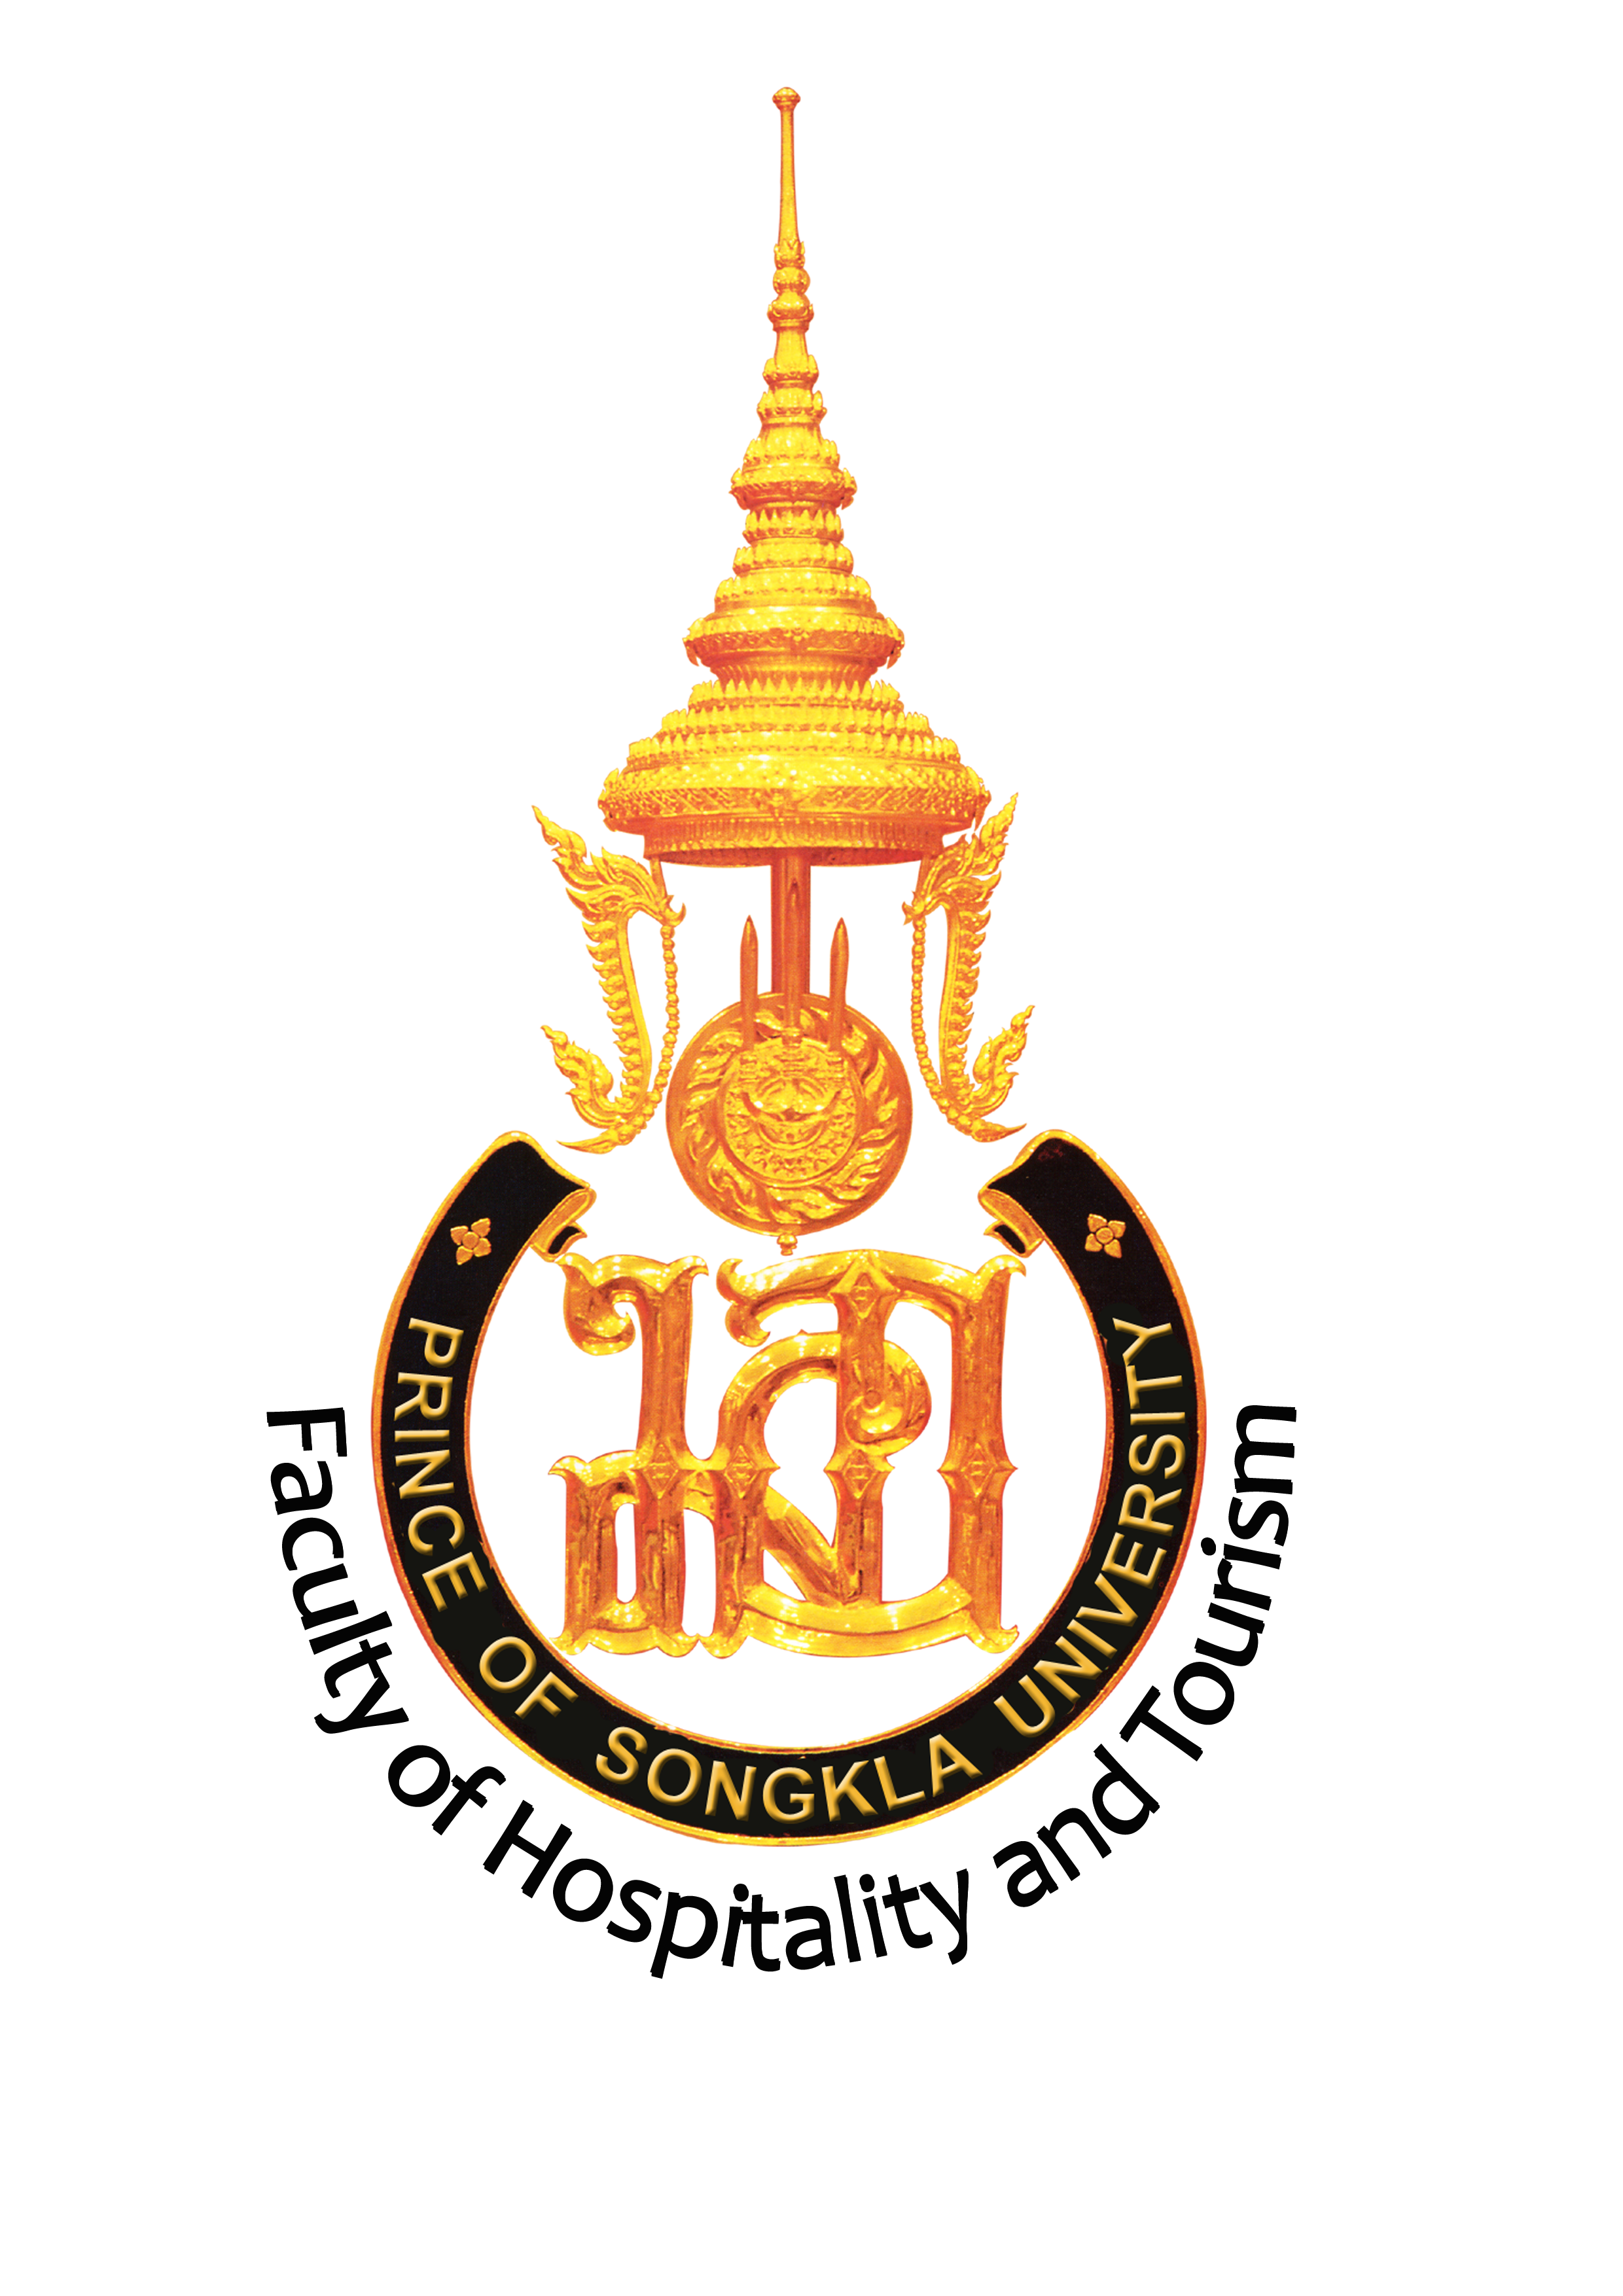 | 
Memorandum of Understanding
Between
Faculty of Hospitality and Tourism, Prince of Songkla University
And
Glorious Sun School of Business and Management, Donghua University

Faculty of Hospitality and Tourism (FHT), Prince of Songkla University, Phuket Campus (PSU), Thailand, and Department of Tourism Management, Donghua University (DHU), Shanghai, P.R.C., believe that mutual benefits can be derived by bridging their two institutions, achieving a closer relationship by linking their scholars and students. Both institutions share strong conviction that mutual understanding among people can be promoted through the establishment of academic links. Therefore, both institutions agree to enter into this Memorandum of Understanding by agreeing to the following:

- Area of implementation
The 3 + 2 Program leading to the MBA in Hospitality and Tourism Management awarded by FHT, PSU.

- Implementation
- The program consists of a 3 year study of B.A. in Tourism Management or other related Bachelor Degrees in Business/Management at DHU and a 2 year study in BBA in Hospitality Management/Tourism Management and MBA in Hospitality and Tourism Management at FHT. The program of study is attached in Annex I.
- Each student will undertake FHT subjects in year 4 at FHT for credit transfer to complete his/her Bachelor’s Degree at DHU. Subjects to be taken will be agreed by both FHT and DHU. The subject match for credit transfer is provided in Annex II.
- FHT will offer a combination of BBA and MBA subjects during the 2 year study at FHT. Students who successfully complete all requirements of FHT’s MBA program will be awarded MBA in Hospitality and Tourism Management.
- FHT will accept DHU students who meet the following criteria into the 3+2 Program:
  - Successfully completed 3rd year of B.A. in Tourism Management or other related Bachelor Degrees in Business/Management at DHU with a minimum GPA of 3.00
  - IELTS 5.0, TOEFL 500, TOEIC 600 or Equivalent
  - FHT may consider accepting students who do not meet the above criteria. This is, however, subject to the condition that the student must register for 2 English subjects in their 1st year at FHT and obtain an average grade of 3.00 for the 2 English subjects.
- DHU students shall have access to all university facilities, assistance, and abide by all rules and regulations of FHT and internship employers in the same manner as any other FHT regular students during the study program period at FHT.
- DHU students participating in the 3+2 Program will enroll and shall pay FHT tuition and fees of 64,000 Baht per person per trimester/semester for a period of 5 trimesters/semesters (2 semesters in year 1 and 3 trimesters in year 2). The fees may be subject to increase after the curriculum revision, with prior notice given to DHU. Students may need to pay additional cost if they cannot complete their studies within the 2 year period.
- DHU students must purchase sufficient health insurance during the study period. In case insurance does not cover all costs, the students must be prepared to pay the remaining costs out-of-pocket.
- Room and board, and all other personal costs (e.g., books, general activity fees, recreation fees, etc.) not specified in this agreement are the responsibility of the students.
- FHT shall provide appropriate academic counselors for DHU students and whatever other counseling assistance is necessary.
- FHT shall issue appropriate documents for visa purposes and ensure that the internship employer issues appropriate documents for work permit in accordance with applicable laws and regulations, although it is the responsibility of the individual student to obtain a visa.

- Duration and Termination of the Agreement
  - This MOU is effective as of the date of signature and will be in force for a period of 5 years.
  - This MOU may be amended any time by written mutual consent of both parties.
  - This MOU may be terminated by either party by the provision of written notice of termination of no less than six months prior to the desired termination date.

Signed on behalf of Faculty of Hospitality and Tourism, Prince of Songkla University | Signed on behalf of Glorious Sun School of Business and Management, Donghua University
_____________________________ | ____________________________
Associate Professor Dr. Prathana Kannaovakun
Dean, Faculty of Hospitality and Tourism
Date____/_____/2015 | Date____/_____/2015

Annex I - Study Plan

Year 1 – 3 Study at DHU

Year 4 BBA and MBA at PSU
Trimester 1 August – December
3 BBA Subjects (choose from subject list provided by FHT)
2 MBA Subjects including
- Managing People for Hospitality and Tourism
- Research Methodology for Hospitality and Tourism

Trimester 2 January – May
3 MBA Subjects and 1 Internship as follows:
- 1 Hospitality/Tourism Specialization Subject
- Research Proposal Development (Non-Credit)
- Seminar in Contemporary Issues and Innovation in Hospitality and Tourism
- Internship

Year 5 MBA at PSU
Trimester 1 August - November
- Marketing Strategy for Hospitality and Tourism
- Managerial Accounting and Finance for Hospitality and Tourism
- Thesis (8 Credits)

Trimester 2 December – March
- 2 Hospitality/Tourism Specialization Subjects
- Thesis (8 Credits)

Trimester 3 April – July
- Writing Research for Publication (Non-credit)
- Thesis (16 Credits)

Annex II – Subject Match for Credit Transfer
FHT PSU | DHU
Internship | Professional Internship
- Research Methodology for Hospitality and Tourism (MBA)  - Research Proposal Development (MBA) | Thesis

